PRACTICE TASK CLASS -4
- search and replace 3rd to last line all the occurance
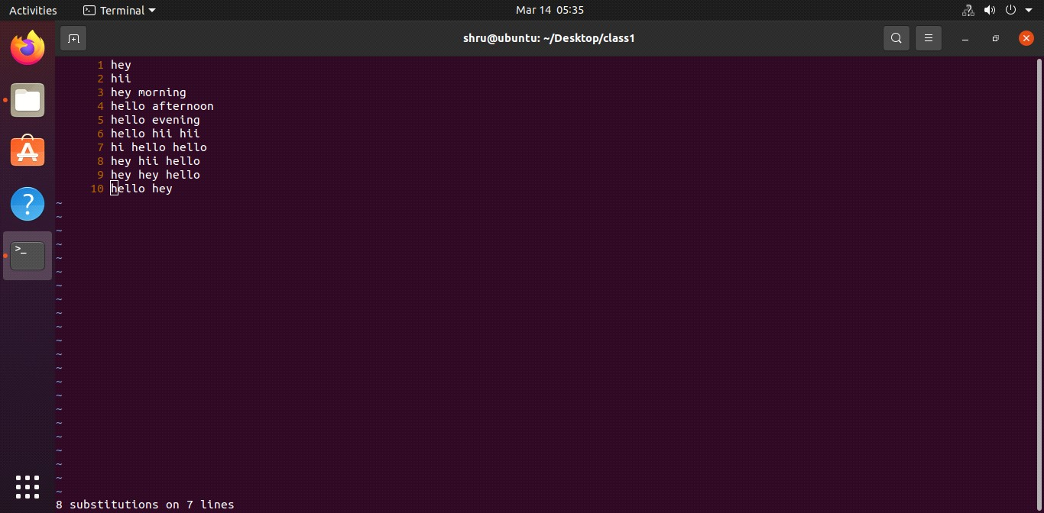
- search and replace 3rd to last line only 1st occurance
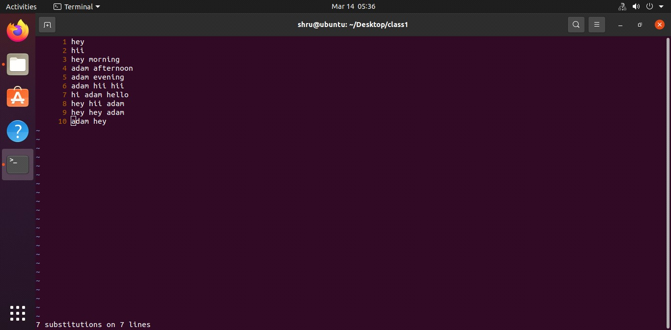
- echo command

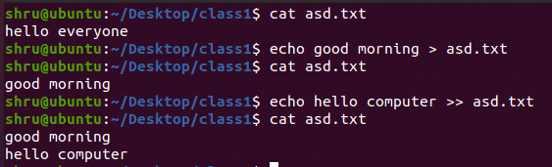

- cat command
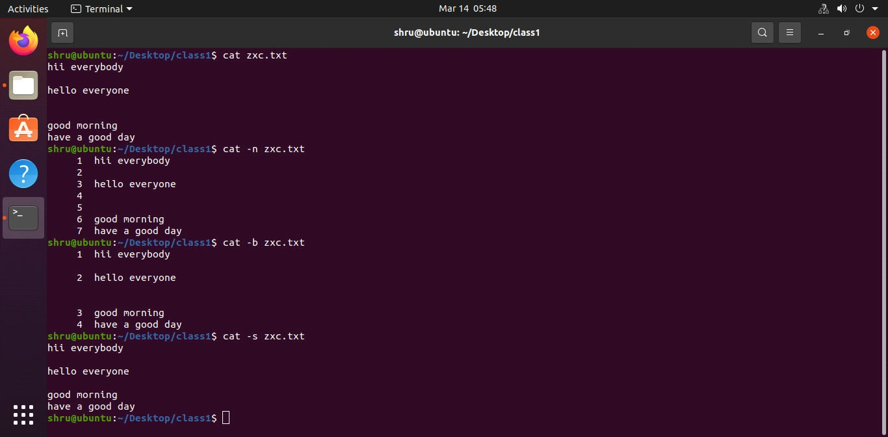
- more command
